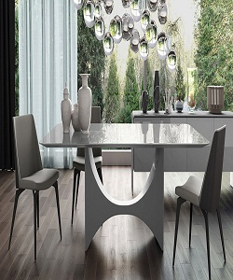

Edra Dining table

$152.95

Availability: In stock

Description

Modern loft-style light wood floor Dining Table. White marble dining table with three unique chairs. Solid units, classic lines and the impeccable elegance of the finishes and covers, this is a collection that can reflect your style.